|  |  |  |
| --- | --- | --- |
| MACARTHUR ELEMENTARY SCHOOL BINGHAMTON - SCHOOL |  |  |
|  |  |  |
| School Detail :- The mission of Douglas MacArthur Elementary School, in partnership with our families and community, is to empower and challenge each student to realize their uniqueness and talent and to achieve the highest potential toward becoming a lifelong learner and contributing member of society.  Creating lifelong learners and future leaders with 21st Century Skills. To create a climate and culture that maximizes every student's potential to learn, lead, and achieve at grade level or higher.  To achieve the highest level of learning for all through the tenacious pursuit of excellence. |  |  |
|  |

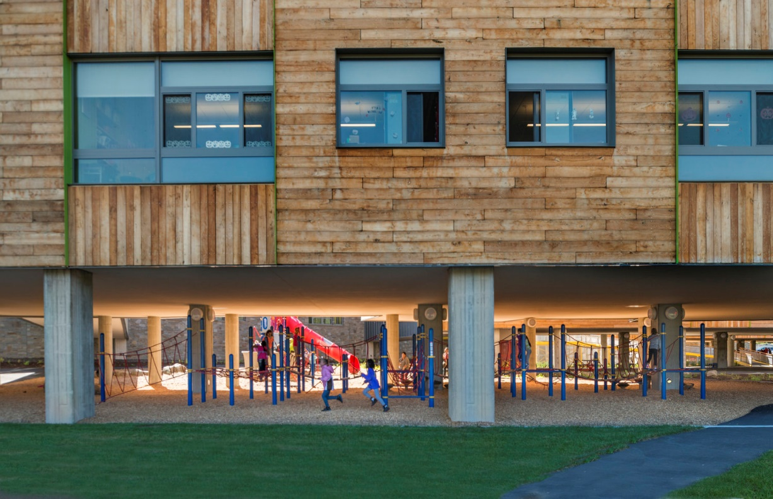

MINIMUM CAPACITY :-

The Minumum intake capacity

of students is between 1400-1510

children

LIBRARY :-

The Libarary is Available.

CANTEEN:-

The Canteen Facility is Available.

BOARDING :-

No availablility of boarding.

SPORTS :-

There are different categories

sports available.

Girls Volleyball

Boys Volleyball

Football